Exists (suppose I want to know weather value exist in column or not)

1. Add source as previously
2. Now click on + and add exist

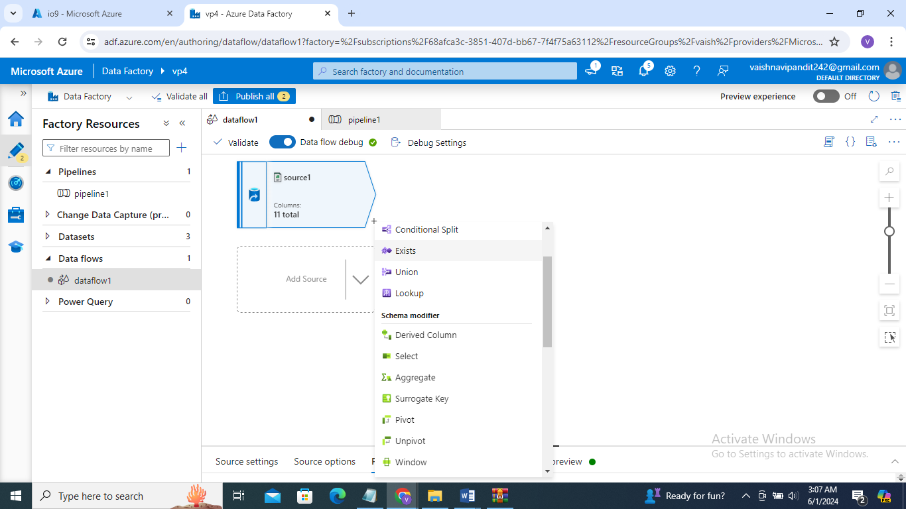

1. Go to exists
2. Add source 2 in left stream
3. Select exists type and column name

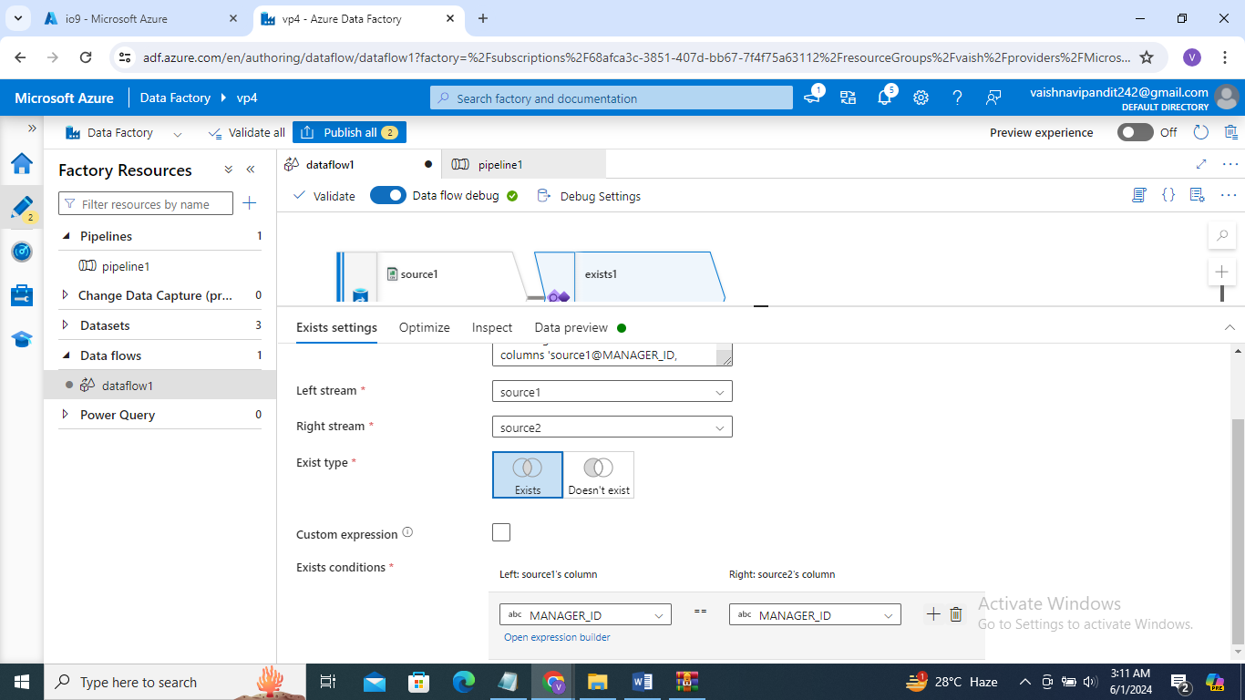

1. Go see preview